Mamdani Type One Fuzzy Inference System For Automatic Control of a Gearbox

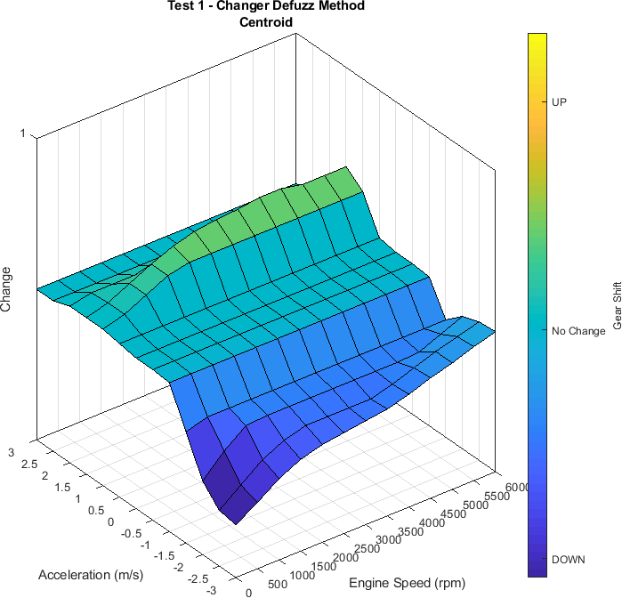

*Figure 1 3D Plot of Shifter Output*

Introduction

With ever stricter environmental laws and increasing use of technology; vehicles systems are becoming more automated. One area is the automatic control of a manual gearbox.

A controller utilising Mamdani type one fuzzy inference systems can be demonstrated to be an effective way of controlling gear changes in a simulated environment.

This report examines some of the issues and explains how fuzzy systems can be used to control a gear box. The performance is tested in a computer environment.

In the appendices; results are presented in the way of graphical outputs from the system

Literature Review

“In a road vehicle, the functions of transmission are to match the running state of the engine to the motion states of the vehicle. The aims are to optimize the fuel economy and the dynamic features, keep the vehicle safe and controllable, and make passengers more comfortable.” (Bai et al., 2006,

1. 145) and “The combination of engine and clutch control in modern automated vehicular powertrains aims to deliver tractive driving torque to the road during shift transients in a manner providing high efficiency and excellent ride quality. While good system design can maximise these requirements for general driving, it is the engine and transmission control systems, including clutch hydraulics, which must provide ideal control of clutch and engine speeds and torques to achieve the best possible results during the shift period” (Walker et al., 2011, p. 1923) explains some of the conflicting requirements of a vehicle transmission system.

With improvements in technology, automatic control of manual gearboxes is more wide spread.

Schöner discusses these improvements in an article published in the Control Engineering Practice journal. “Automatic transmissions, which up to recently relied on complex hydraulic control systems, are being transformed into mechatronical units. Manual transmissions are being automated with complex actuator and sensor systems in order to give a similar shifting comfort compared to their hydraulic counterparts, but with a higher efficiency.” (Schöner, 2004, p. 1347)

“Driving factor for such innovations are of course functional improvements which only, or much more efficiently, can be reached using electronic technologies. In vehicles the increase of comfort, safety, and reliability is the main goal together with the improvement in driving performance, fuel consumption, emissions, but also production processes (Schöner, 2004, p. 1343)

An automated control system should be able to perform to at least the level of a competent driver operating a manual gear box.

“Drivability is the key factor for the automated manual transmission. It includes fast response to the driver’s demand and the driving comfort.” (Jiang et al., 2017) Addressing smooth gear changes acknowledged by Kahlbau and Bestle “Based on the fact that a shift event generally corresponds to an acceleration change, the question about an optimum transition arises. The paper tackles this general question by formulating a bi-criterion optimization problem minimizing jerk and change of jerk simultaneously” (Kahlbau and Bestle, 2013)

Lei et al. discuss “Recognizing various driving conditions in real time and adjusting control strategy accordingly in automatic transmission vehicles are important to improve their adaptability to the external environment.” and “Vehicle driving environments vary widely; not only pavement type is

complex, but also traffic flow condition under the same pavement type is always different. Different driving environment has different requirements for vehicle.” (Lei et al., 2015)

One method of flexible systems control is to use fuzzy logic. Pioneered by Lotfi Zadeh he explains “The concept in question is that of a fuzzy set, is, a "class" with a continuum of grades of membership.” (Zadeh, 1965, p. 339) as opposed to Boolean values or conventional crisp sets.

Fuzzy logic can be used for pattern recognition and a “model of learning systems” (Wee and Fu, 1969, p. 215) and often used in control systems. One of the first published was by Mamdani for control of a steam engine. He states “Results have shown that this approach can give similar, if not better, results compared with classical controllers. Its simplicity can therefore make it viable in many practical situations. This is especially true when one considers other special features incorporated in the computer program to aid human interaction. For example, it is possible to 'tune' the above controller online, by modifying weak or bad rules that give rise to unacceptable actions.” (Mamdani, 1974).

Minh and Rashid explain fuzzy logic is already used for vehicle systems, such as braking systems. “… system relies on fuzzy logic control to create an intelligent controller that can use uncertain and imprecise information. The use of fuzzy logic can help circumvent the need for rigorous mathematical modeling. In the automotive industry, we have seen the successful application of fuzzy logic to control the anti-lock braking system (ABS).”

They designed a fuzzy logic system to control clutches in hybrid vehicles. “The controller will determine the shifting connection mode via the position and the rate of throttle operation. The changing gear mode is selected based on the current torque load and the vehicle velocity matching with the engine speed.” (Minh and Rashid, 2012).

“A method for velocity correction parameters calculation by the fuzzy algorithm was presented, based on random load standard deviation; the alteration rate of the load steady state value and throttle position was analyzed.” (Cao et al., 2017) was used to control a tractor.

In a fuzzy control system for a transmission “ Usually the automatic transmission vehicle chooses vehicle speed and throttle opening as gearshift control parameters.” (Fu et al., 2013, p. 1234).

Most of the literature for vehicle transmissions systems are related to clutch control and not necessarily gear selection of a manual dry clutch gear box.

System Overview

Gear changes are chosen by the driver of a vehicle with a manual gear box due to factors including:

* + Road and Weather Conditions
  + Driving style
  + Comfort
  + Urgency
  + Fuel Economy

This report suggests one way of using fuzzy logic to automatically control the gear box of a vehicle with six forward gears and one reverse gear.

The control system needs to maintain a balance of unnecessary gear changes against performance and fuel economy.

The original design used a single Mamdani type one fuzzy Inference system. This was proving to be quite unwieldly and early on a decision was made to break the complete system into smaller components.

Please refer to the system block diagram in Appendix F.

The whole system was developed and tested using MATLAB **2018b**.

An outer MATLAB function named Drive which is the interface for the whole system.

Drive calls the first fuzzy system called Shifter. Shifter decides if the current gear is suitable, the output is related to any change up or down.

Drive then calls the second system, known as Gear Box. The other inputs passed to Drive along with the Shifter output from the previous system are used to calculate the correct gear.

The outputs of Gear Box, the new gear and speed is returned to Drive, which is returned to the calling function.

The outputs can be fed straight back into Drive, to create a closed loop system.

This modular system and individual components with the same interface can be changed without affecting the rest of the system.

Vehicle specific configuration is held in one file. The system can be quickly changed for various vehicles by changing this configuration file.

Design Detail

Config File

The config file contains all the vehicle specific configuration.

1. max speed – Maximum vehicle speed (km/h)
2. tyre diameter – The tyre diameter (m)
3. ratio rev – Final reverse ratio
4. ratio1 to ratio6 – Final ratio of the forward gears

There are eight RPM ranges for different levels of acceleration described:

1. Stopped – Engine stopped
2. Idle – Engine Idling
3. Normal – Normal driving range
4. Low – Low acceleration
5. Medium – Medium acceleration
6. High – High acceleration
7. Limit – Maximum engine speed
8. Change Down – Changing down speed

Shifter

In the changer file, a type one Mamdani fuzzy system named Shifter is created from the Config file. The shifter has two fuzzy inputs: (See Appendix A1)

Engine speed (rpm), the ranges are from the Config file. Acceleration (m/s2) from the following five ranges:

1. Braking - Negative
2. None – Centred around zero
3. Accelerate – Normal acceleration
4. Quicker – Quicker acceleration
5. Hard – Maximum acceleration

The output of the shifter is a fuzzy output which is the amount of gear change between -1 and 1.

Negative numbers signify a change from a higher gear to a lower gear. Conversely positive numbers signify a change up from a lower gear to a higher gear. No change required is centred around 0. (See Appendix A2)

The Shifter must try and save unnecessary gear changes, especially at low levels of acceleration and deceleration. At normal acceleration the gears need to change at the most fuel efficient time, during the engines high band of torque. For high levels of acceleration, gears changes only happen at maximum power, which is generally less than maximum engine RPM.

Other forces of acceleration need to be a balanced between the two.

At all times of normal driving, the engine speed needs to be kept in the RPM range between the low end of the torque and maximum power.

As the vehicle is slowing down, the gears need to be changed down to higher ratios, this must be done smoothly. There is a balance between using the engine assisted braking and not over revving in low gears.

Rules are created within a matrix A, each cell represents a combination of rules. The relevant fuzzy rule number is shown in each cell. Red cells describe a change up and blue cells represent a change down. No change is shown with grey. (See Appendix A3)

Matrix A

|  |  |  |  |  |  |  |
| --- | --- | --- | --- | --- | --- | --- |
|  | | Acceleration | | | | |
| Braking | None | Accelerate | Quicker | Hard |
| RPM Range | Stopped | 11 | 11 | 11 | 11 | 11 |
| Idle | 22 | 23 | 21 | 21 | 21 |
| Normal | 31 | 32 | 33 | 34 | 35 |
| Low | 41 | 42 | 43 | 44 | 45 |
| Medium | 51 | 52 | 53 | 54 | 55 |
| High | 61 | 62 | 63 | 64 | 65 |
| Limit | 71 | 72 | 73 | 74 | 75 |
| Down | 81 | 82 | 83 | 84 | 85 |

This produces a 3D plot. (See Appendix C1)

The output of the Shifter system is used as an input to the Gear box system.

Gear Box

The transmission file contains the second type one Mamdani fuzzy system known as Gear Box. The four fuzzy inputs are: (See Appendix B1)

1. Current gear, -1 for reverse, 0 for neutral and 1 to 6 for the forward gears.
2. Gear Lever, position in the vehicle, -2 for park, -1 for reverse, 0 for neutral and 1 for drive.
3. Speed, of the vehicle in km/h.
4. Shifter, the shifter output from the previous fuzzy system.

The Gearbox fuzzy output is the new selected gear: (See Appendix B2) Reverse is -1, neutral is 0 and 1 to 6 are the forward gears.

There are certain rules designed to protect the gears,

1. Park is only engaged while the vehicle is stationary.
2. Reverse can only be engaged while the vehicle is stationary or moving backwards.
3. Neutral can be engaged at any time.
4. Drive can only be engaged while the vehicle is stationary or moving forwards.

There are two rule sets, matrices B and C.

Each cell represents a combination of rules. (See Appendix B3)

The output gear is shown in each cell. Red cells describe forward gears and blue cells represent reverse. Neutral is shown with grey.

Matrix B

|  |  |  |  |  |
| --- | --- | --- | --- | --- |
|  | | Speed | | |
| Reverse | Stopped | Forward |
| Gear Lever Position | Park |  | 0 |  |
| Reverse | -1 | -1 | 0 |
| Neutral | 0 | 0 | 0 |
| Drive |  | 1 | 1 - 6 |

The second rule set (Matrix C) is used when the gear lever is in the Drive position and there is forward motion.

These rules decide which gear is next, if there is a change or down.

The cells show the output gear. Red cells describe a change up and blue cells represent a change down.

Matrix C

|  |  |  |  |  |  |  |  |
| --- | --- | --- | --- | --- | --- | --- | --- |
|  | | Current Gear | | | | | |
|  | | 1 | 2 | 3 | 4 | 5 | 6 |
| Change | Down | 1 | 1 | 2 | 3 | 4 | 5 |
| None | 1 | 2 | 3 | 4 | 5 | 6 |
| Up | 2 | 3 | 4 | 5 | 6 | 6 |

Drive

A function named Drive in the drive file controls the two fuzzy systems. This has five inputs:

1. Engine speed (rpm).
2. Acceleration of the vehicle (m/s2).
3. Current Gear – Reverse is -1, Neutral is 0 and 1 to 6 are forward gears.
4. Gear Lever Position – Park is -2, Reverse is -1, Neutral is 0 and 1 for Drive.
5. Speed of the vehicle (km/h).

There are two outputs:

1. New Gear – Reverse is -1, Neutral is 0 and 1 to 6 are forward gears.
2. New speed of the vehicle (km/h).

The speed in km/h is calculated from the following formula:

𝑠𝑝𝑒𝑒𝑑 =

𝑟𝑝𝑚

𝑟𝑎𝑡𝑖𝑜

𝜋 𝑡𝑦𝑟𝑒𝑑𝑖𝑎𝑚𝑒𝑡𝑒𝑟 60

1000

Multiplying the speed in km/h by 0.621371 gives the speed in mph.

Drive also implements the speed limiter. If the new speed is more than the limit set in the Config file, then the speed is set at the limit.

The outputs can be fed straight back into Drive, to create a closed loop system.

Testing

Testing and tuning were made much easier with the modular design of the whole system. Each system could be tested and tuned individually. This significantly speeded up the testing process as smaller specific tests could be run.

The data for config file contains the details of a vehicle with a 2L 140PS diesel engine that has a peak torque at 1750 to 2500 rpm and maximum power at 4200 rpm. Connected to a Skoda 6 speed 02Q gearbox. The tyres are size 225/45R17 and with a speed limiter set at 150 mph.

Initially the two fuzzy systems were checked individually against the fuzzy rules with the ruleview function in MATLAB. Once the components appeared to be working satisfactorily, the whole system was tested. The drive function simplified testing further by providing a simple and consistent way to run the system.

Nine test MATLAB scripts calling the Drive function with various parameter combinations were written to aid testing. They produce both console text outputs and graphs. It is easy to visually compare different settings and the graphs can be used to check certain data points. If any problems are discovered the text output can be examined to find the exact values used in the systems. This data can be replicated in the MATLAB ruleview tool to find and correct, the problematic rules.

Defuzzification test scripts:

1. The Shifter fuzzy system was tested with thirteen different values of acceleration and engine speeds from 1300rpm up to 6000rpm in steps of 100 rpm. This produces a 3D graph of gear change vs acceleration and engine speed. Total test time 2 seconds. (See Appendix C1)

1a. Acceleration in Forward Gears with different Shifter defuzzification methods. Each method takes 54 seconds to test. (See Appendix C2)

The Gear Box system had two tests. The graphs show engine speed rpm against vehicle speed.

4a. Acceleration in Forward Gears with different Gear Box defuzzification methods. Each method takes 54 seconds to test. (See Appendix C3)

1. Plot the output with the gear position lever in park, neutral and reverse at maximum acceleration from engine speeds of 800 rpm to 6000 rpm in steps of 100 rpm. Total test time 79 seconds. (See Appendix C4)

The whole system had five tests. The graphs show engine speed rpm against vehicle speed.

1. With the transmission in drive, the range of engine speed from 800 rpm to 6000 rpm in steps of 100 rpm in each forward gear is tested. Test time 157 seconds. (See Appendix C5)
2. With the transmission in drive and first gear selected, the engine speed is increased from 1300 rpm until the change point for each gear, up to a maximum of 6000 rpm. Total test time 51 seconds. (See Appendix C6)
3. With the transmission in drive and first gear selected, the engine speed is increased from idle until the change point for each gear, up to a maximum of 6000 rpm. This test is repeated for four values of acceleration. Total test time 134 seconds. (See Appendix C7)
4. The test starts with the transmission in drive, sixth gear selected and the engine speed set for an equivalent vehicle speed of 155mph. The engine speed is decreased at intervals of 100 rpm. Until the change down point for each gear is reached. The test is repeated for four values of deceleration. Total test run time 134 seconds. (See Appendix C8)
5. The output of test 3, normal gear changes at acceleration rate of 3 m/s2, was compared to the output of a website “Gear Ratio and RPM to MPH Calculator”. (See Appendix E).

The results are nearly identical. The only slight difference in output is due to scaling and rounding of the testing script to the nearest 100 rpm.

The total time to run all the tests is approximately 10 minutes on the laptop running MATLAB.

Tuning

Initially the system was configured with as few fuzzy rules as possible.

Examining the 3D graph from the first test several sharp angles and spikes were observed.

The spikes were at boundary conditions of the rules. Adding more rules started to cause other undesirable side effects. It was decided to add all the rules in full and comment out the ones which were not required.

The system then behaved as intended, but there were still sharp edges at the boundaries between the fuzzy inputs for the Shifter fuzzy function. Changing inputs from polygons to gaussian curves removed the harshness. (See Appendix D)

There was a large jump in the levels of acceleration. Two more fuzzy input ranges Medium and Quicker were added fill in between the extremes of the original system.

The change down of gears during deceleration was harsh, resulting in high engine speed rpm in the new lower gear. The change down rpm range was moved to a lower range of engine speed rpm.

The output of the Shifter fuzzy function is a simple result to signify a change up or down. The Shifter was tested using different defuzzification methods. (See Appendix C1) The only difference to the resulting system, is Centroid causes gear changes at slightly lower engine speeds than the other methods.

The output of the Gear Box fuzzy function is a number representing which gear should be selected. This function too was tested using different defuzzification methods. (See Appendix C2). There were only very slight variations between the methods. The Drive function rounds the output to a whole integer as the result is used for array indexing in the test scripts.

Critical Analysis

What appears to be a simple decision to change gear in a vehicle, proves to be a quite a complex task for a machine to do. Testing was only done within MATLAB.

Further testing could include:

1. Modelling in Simulink with Simscape Driveline.
2. Using real test data such as New European Driving Cycle (NEDC) or Worldwide Light vehicle Testing Protocol (WLTP) which will be used in the from 2020 onwards.
3. Trying the system in a real vehicle.
4. Different vehicle configurations could be tried to test different gearbox ratios.

Even though the system performs well, there are many improvements which could be made:

1. Simplify the fuzzy rules using Karnaugh maps.
2. If difference in rpm between current gear and next gear is small, then skip that gear.
3. Have an additional deceleration RPM range.
4. Allow for different numbers of gears, not just six forward and one reverse.
5. For better flexibility have a fuzzy system for each individual gear.
6. Use an adaptive neuro-fuzzy inference system (ANFIS) system for best performance.
7. “Integrated powertrain control feature, which coordinates the control of transmission (gear shifting) and engine (throttle).” (Kim et al., 2007, p. 474)
8. Allow for “undesired gearshift under cornering condition” (Fu et al., 2013, p. 1234)
9. “The study of special driving environment including curve, the low adhesion road (snow, muddy, and slippery road), and bumpy road” (Lei et al., 2015)

Reflection

If I were to re-attempt this project, I would make the following changes:

1. Start with gaussian inputs and not trapezium or triangular.
2. Have every rule combination in the beginning and eliminate rules not required.
3. Use only metric units. Initially I started with a mixture of metric and imperial units, which caused extra coding and rounding errors.
4. I wasted a lot of time with a problem of the graph legends not matching the plotted lines. This was resolved by storing the results in an array and plotting at the end.
5. Saving the data and plotting later would have saved time when changing the properties of graphs such as titles.
6. Testing took a lot longer than developing the initial system.

Conclusion

The system demonstrates utilising Mamdani type one fuzzy inference systems can be an effective way of controlling gear changes in a simulated environment.

In the appendices; results are presented in the way of graphical outputs from the system

The system development time was very quick. Time could be spent on testing and tuning and not writing lots of code. It would be difficult to program such a flexible system using conventional programming languages.

The systems in this report can be used as a basis for a more comprehensive system.

References

Bai, Y., Zhuang, H. and Wang, D. (2006) *Advanced fuzzy logic technologies in industrial applications*, London, Springer.

Block Layer (2018) *Gear Ratio and RPM to MPH Calculator with Auto Shift and Tracer.* [Online]. Available from: https://[www.blocklayer.com/rpm-geareng.aspx](http://www.blocklayer.com/rpm-geareng.aspx) [Accessed 27/12/2018].

Cao, Q., Zhou, Z. and Zhang, M. (2017) ‘Fuzzy Adaptive Shift Schedule of Tractor Subjected to Random Load’, *Mathematical Problems in Engineering*, vol. 2017, no. 6, pp. 1–8.

Fu, Y., Zhang, W. G., Lei, Y. L. and Liu, H. B. (2013) ‘Research for Cornering Gearshift Strategy of Automatic Transmission Vehicles Based on Fuzzy Inference’, *Applied Mechanics and Materials*, 336-338, pp. 1234– 1240.

Jiang, D., Huang, Y., Zuo, Z. and Li, H. (2017) ‘Drivability Improvement Control for Vehicle Start-Up Applied to an Automated Manual Transmission’, *Shock and Vibration*, vol. 2017, pp. 1–12.

Kahlbau, S. and Bestle, D. (2013) ‘Optimal Shift Control for Automatic Transmission #’, *Mechanics Based Design of Structures and Machines*, vol. 41, no. 3, pp. 259–273.

Kim, D., Peng, H., Bai, S. and Maguire, J. M. (2007) ‘Control of Integrated Powertrain With Electronic Throttle and Automatic Transmission’, *IEEE Transactions on Control Systems Technology*, vol. 15, no. 3, pp. 474–482.

Lei, Y., Liu, K., Zhang, Y., Fu, Y., Liu, H., Lin, G. and Tang, H. (2015) ‘Adaptive Gearshift Strategy Based on Generalized Load Recognition for Automatic Transmission Vehicles’, *Mathematical Problems in Engineering*, vol. 2015.

Mamdani, E. H. (1974) ‘Application of fuzzy algorithms for control of simple dynamic plant’, *Proceedings of the Institution of Electrical Engineers*, vol. 121, no. 12, p. 1585.

Minh, V. T. and Rashid, A. A. (2012) ‘Automatic control of clutches and simulations for parallel hybrid vehicles’,

*International Journal of Automotive Technology*, vol. 13, no. 4, pp. 645–651.

Schöner, H.-P. (2004) ‘Automotive mechatronics’, *Control Engineering Practice*, vol. 12, no. 11, pp. 1343– 1351.

Walker, P. D., Zhang, N. and Tamba, R. (2011) ‘Control of gear shifts in dual clutch transmission powertrains’,

*Mechanical Systems and Signal Processing*, vol. 25, no. 6, pp. 1923–1936.

Wee, W. and Fu, K. (1969) ‘A Formulation of Fuzzy Automata and Its Application as a Model of Learning Systems’, *IEEE Transactions on Systems Science and Cybernetics*, vol. 5, no. 3, pp. 215–223.

Zadeh, L. A. (1965) ‘Fuzzy sets’, *Information and Control*, vol. 8, no. 3, pp. 338–353.

Appendices

Appendix A1 16

Shifter Fuzzy Inputs 16

Appendix A2 17

Shifter Fuzzy Output 17

Appendix A3 18

Shifter Fuzzy Rules 18

Appendix B1 19

Gear Box Fuzzy Inputs 19

Appendix B2 21

Gear Box Fuzzy Output 21

Appendix B3 22

Gear Box Fuzzy Rules 22

Appendix C1 23

Test 1 - Shifter Defuzzification Method 23

Appendix C2 24

Test 1a - Gear Box Defuzzification Methods 24

Appendix C3 25

Test 4a – Acceleration In Forward Gears 25

Appendix C4 26

Test 2 – Maximum RPM In Non-Forward Gears 26

Appendix C5 27

Test 3 – Maximum RPM In Forward Gears 27

Appendix C6 28

Test 4 – Acceleration in Forward Gears Starting At Previous Speed 28

Appendix C7 29

Test 5 – Acceleration in Forward Gears Starting At 1300 rpm 29

Appendix C8 30

Test 6 – Deceleration in Forward Gears 30

Appendix D1 31

Current version of Shifter 31

Previous versions of Shifter 31

Appendix D2 32

Current version of Gear Box 32

Appendix E 33

Test 7 - Comparison 33

Appendix F 34

System Block Diagram 34

## Shifter Fuzzy Inputs

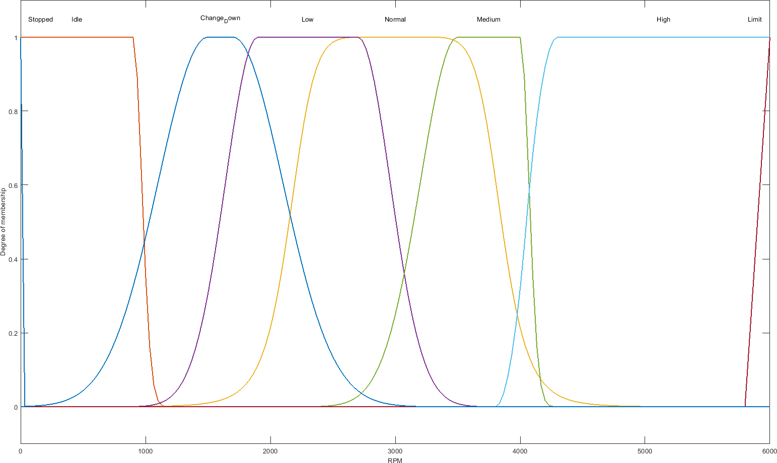µ

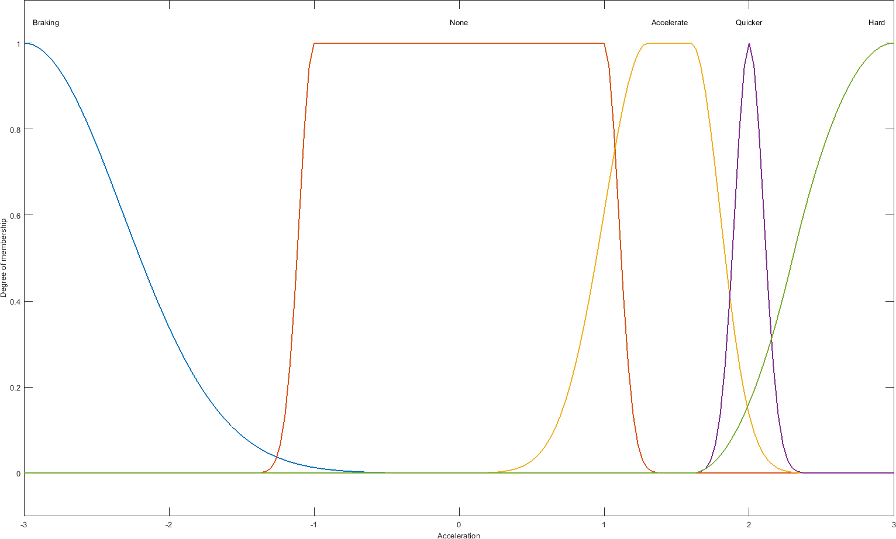*Figure 2: Shifter RPM Range Input*

µ

*Figure 3: Shifter Acceleration Range Input*

## Shifter Fuzzy Output

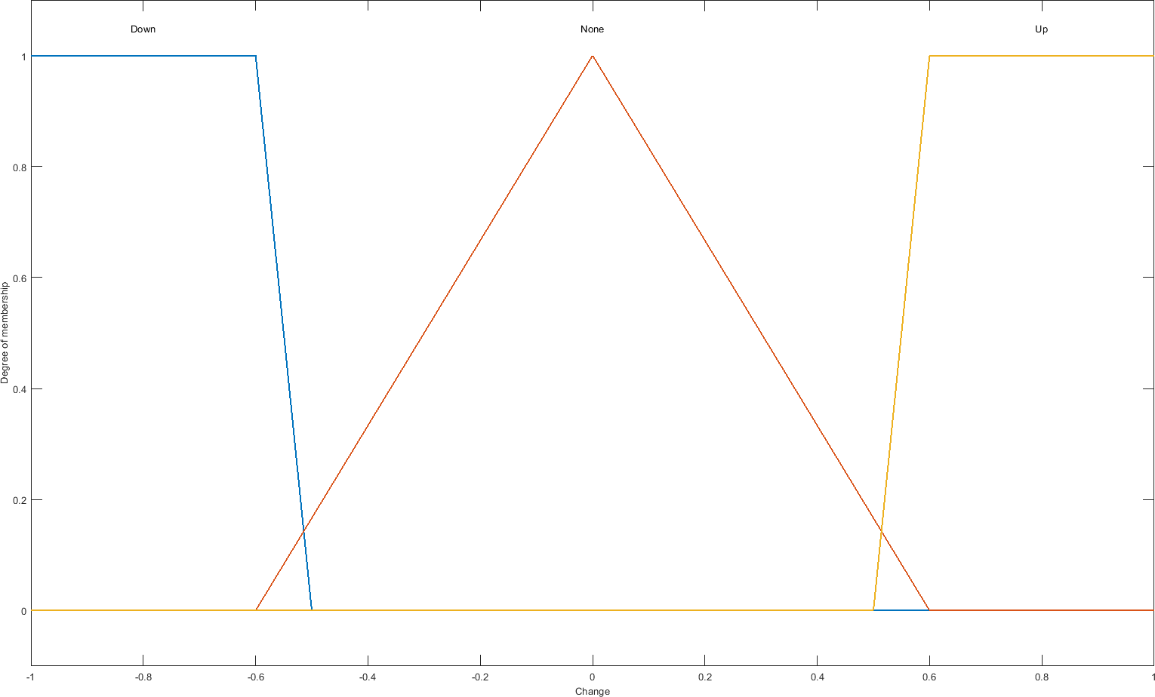µ

*Figure 4: Shifter Output*

# Appendix A3

## Shifter Fuzzy Rules

1. If (RPM is Stopped) then (Change is None) (1)
2. If (RPM is Idle) then (Change is None) (1)
3. If (RPM is Idle) and (Acceleration is Braking) then (Change is Down) (1)
4. If (RPM is Idle) and (Acceleration is None) then (Change is Down) (1)
5. If (RPM is Normal) and (Acceleration is Braking) then (Change is None) (1)
6. If (RPM is Normal) and (Acceleration is None) then (Change is None) (1)
7. If (RPM is Normal) and (Acceleration is Accelerate) then (Change is None) (1)
8. If (RPM is Normal) and (Acceleration is Quicker) then (Change is None) (1)
9. If (RPM is Normal) and (Acceleration is Hard) then (Change is None) (1)
10. If (RPM is Low) and (Acceleration is Braking) then (Change is None) (1)
11. If (RPM is Low) and (Acceleration is None) then (Change is None) (1)
12. If (RPM is Low) and (Acceleration is Accelerate) then (Change is Up) (1)
13. If (RPM is Low) and (Acceleration is Quicker) then (Change is None) (1)
14. If (RPM is Low) and (Acceleration is Hard) then (Change is None) (1)
15. If (RPM is Medium) and (Acceleration is Braking) then (Change is None) (1)
16. If (RPM is Medium) and (Acceleration is None) then (Change is None) (1)
17. If (RPM is Medium) and (Acceleration is Accelerate) then (Change is None) (1)
18. If (RPM is Medium) and (Acceleration is Quicker) then (Change is Up) (1)
19. If (RPM is Medium) and (Acceleration is Hard) then (Change is None) (1)
20. If (RPM is High) and (Acceleration is Braking) then (Change is None) (1)
21. If (RPM is High) and (Acceleration is None) then (Change is Up) (1)
22. If (RPM is High) and (Acceleration is Accelerate) then (Change is Up) (1)
23. If (RPM is High) and (Acceleration is Quicker) then (Change is Up) (1)
24. If (RPM is High) and (Acceleration is Hard) then (Change is Up) (1)
25. If (RPM is Limit) and (Acceleration is Braking) then (Change is None) (1)
26. If (RPM is Limit) and (Acceleration is None) then (Change is Up) (1)
27. If (RPM is Limit) and (Acceleration is Accelerate) then (Change is Up) (1)
28. If (RPM is Limit) and (Acceleration is Quicker) then (Change is Up) (1)
29. If (RPM is Limit) and (Acceleration is Hard) then (Change is Up) (1)
30. If (RPM is Change_Down) and (Acceleration is Braking) then (Change is Down) (1)
31. If (RPM is Change_Down) and (Acceleration is None) then (Change is None) (1)
32. If (RPM is Change_Down) and (Acceleration is Accelerate) then (Change is None) (1)
33. If (RPM is Change_Down) and (Acceleration is Quicker) then (Change is None) (1)
34. If (RPM is Change_Down) and (Acceleration is Hard) then (Change is None) (1)

# Appendix B1

## Gear Box Fuzzy Inputs

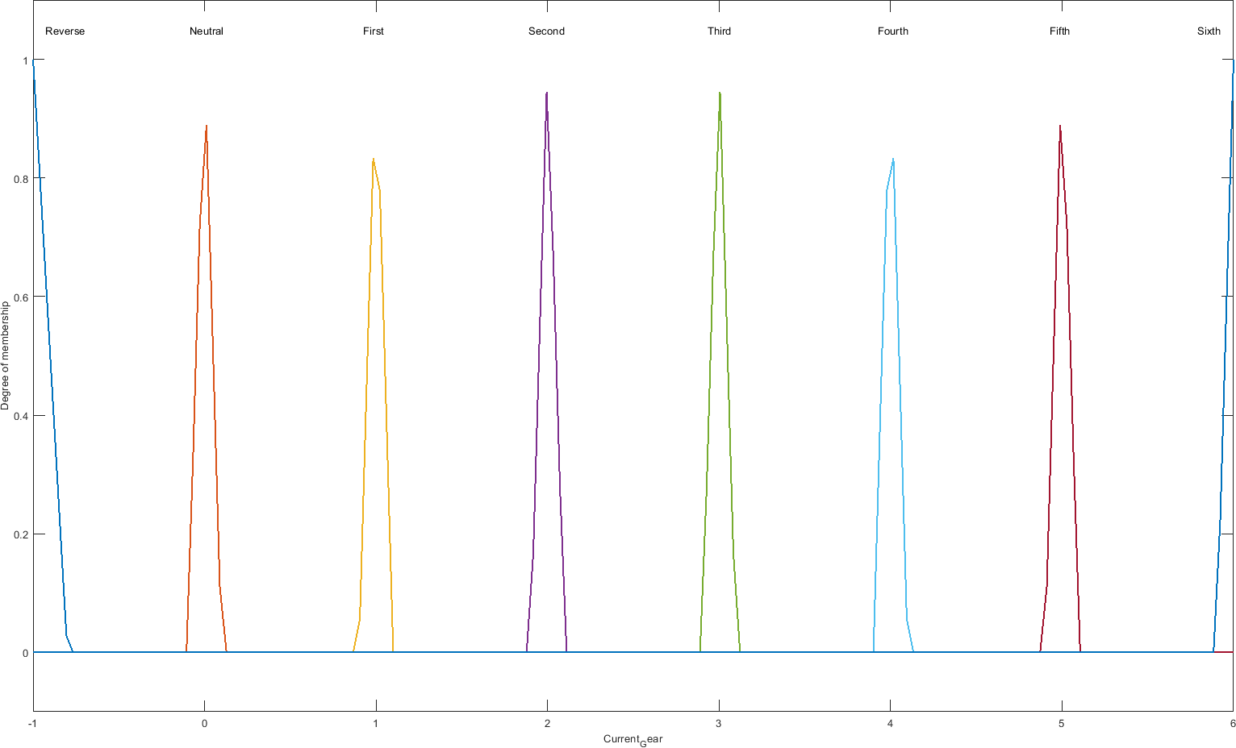µ

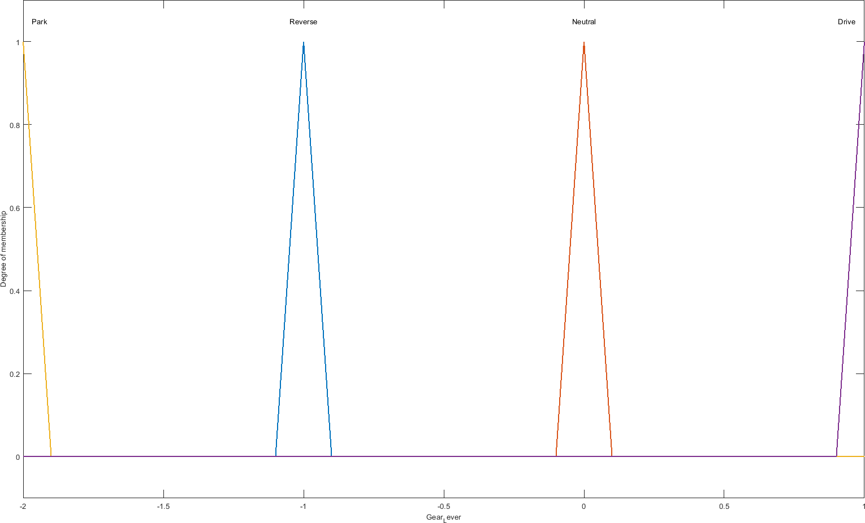*Figure 5: Current Gear Input*

µ

*Figure 6: Gear Lever Position Input*

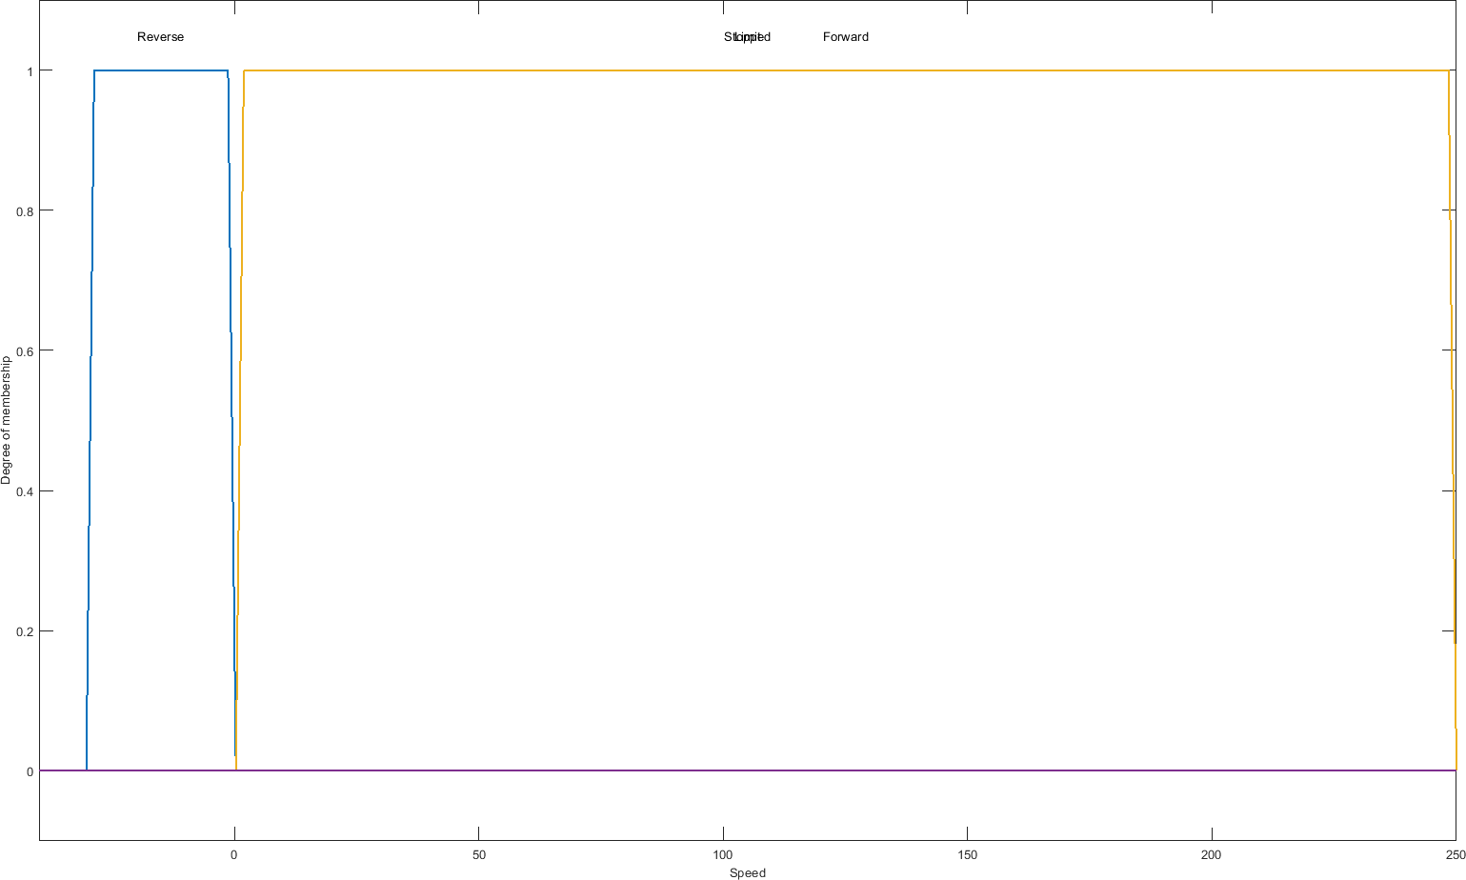µ

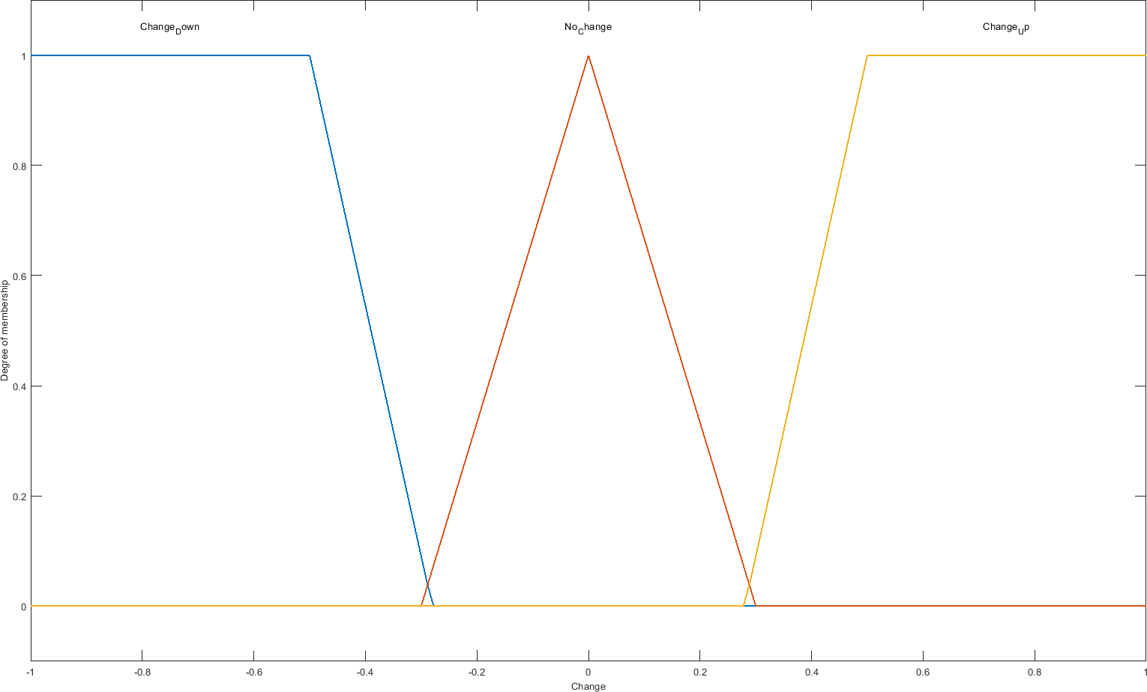*Figure 7: Speed Input*

µ

*Figure 8: Shifter Input*

## Gear Box Fuzzy Output

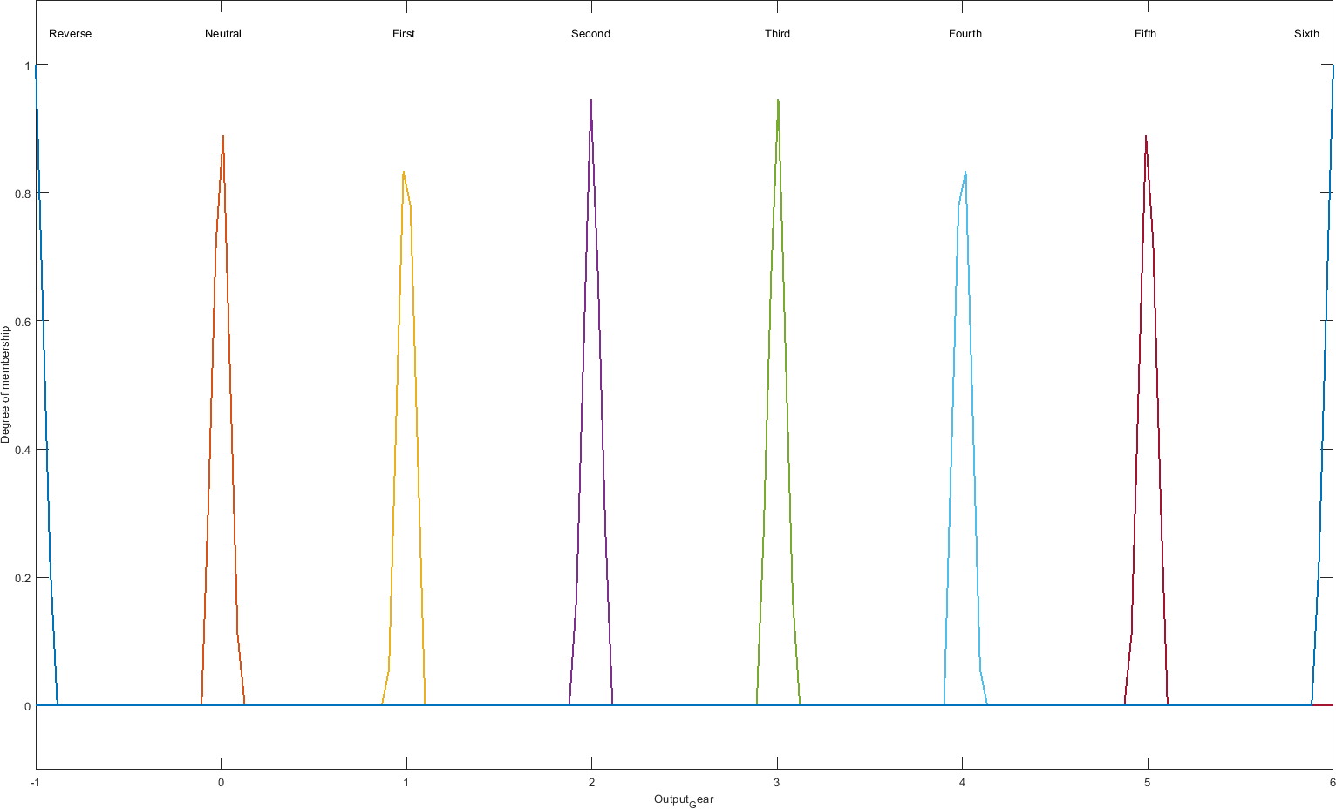µ

*Figure 9: Gear Box Output*

# Appendix B3

## Gear Box Fuzzy Rules

1. If (Gear_Lever is Neutral) then (Output_Gear is Neutral) (1)
2. If (Gear_Lever is Drive) and (Speed is Stopped) then (Output_Gear is First) (1)
3. If (Gear_Lever is Reverse) and (Speed is Stopped) then (Output_Gear is Reverse) (1)
4. If (Gear_Lever is Reverse) and (Speed is Reverse) then (Output_Gear is Reverse) (1)
5. If (Gear_Lever is Reverse) and (Speed is Forward) then (Output_Gear is Neutral) (1)
6. If (Gear_Lever is Park) and (Speed is Stopped) then (Output_Gear is Neutral) (1)
7. If (Current_Gear is First) and (Gear_Lever is Drive) and (Speed is Forward) and (Change is Change_Down) then (Output_Gear is First) (1)
8. If (Current_Gear is First) and (Gear_Lever is Drive) and (Speed is Forward) and (Change is No_Change) then (Output_Gear is First) (1)
9. If (Current_Gear is First) and (Gear_Lever is Drive) and (Speed is Forward) and (Change is Change_Up) then (Output_Gear is Second) (1)
10. If (Current_Gear is Second) and (Gear_Lever is Drive) and (Speed is Forward) and (Change is Change_Down) then (Output_Gear is First) (1)
11. If (Current_Gear is Second) and (Gear_Lever is Drive) and (Speed is Forward) and (Change is No_Change) then (Output_Gear is Second) (1)
12. If (Current_Gear is Second) and (Gear_Lever is Drive) and (Speed is Forward) and (Change is Change_Up) then (Output_Gear is Third) (1)
13. If (Current_Gear is Third) and (Gear_Lever is Drive) and (Speed is Forward) and (Change is Change_Down) then (Output_Gear is Second) (1)
14. If (Current_Gear is Third) and (Gear_Lever is Drive) and (Speed is Forward) and (Change is No_Change) then (Output_Gear is Third) (1)
15. If (Current_Gear is Third) and (Gear_Lever is Drive) and (Speed is Forward) and (Change is Change_Up) then (Output_Gear is Fourth) (1)
16. If (Current_Gear is Fourth) and (Gear_Lever is Drive) and (Speed is Forward) and (Change is Change_Down) then (Output_Gear is Third) (1)
17. If (Current_Gear is Fourth) and (Gear_Lever is Drive) and (Speed is Forward) and (Change is No_Change) then (Output_Gear is Fourth) (1)
18. If (Current_Gear is Fourth) and (Gear_Lever is Drive) and (Speed is Forward) and (Change is Change_Up) then (Output_Gear is Fifth) (1)
19. If (Current_Gear is Fifth) and (Gear_Lever is Drive) and (Speed is Forward) and (Change is Change_Down) then (Output_Gear is Fourth) (1)
20. If (Current_Gear is Fifth) and (Gear_Lever is Drive) and (Speed is Forward) and (Change is No_Change) then (Output_Gear is Fifth) (1)
21. If (Current_Gear is Fifth) and (Gear_Lever is Drive) and (Speed is Forward) and (Change is Change_Up) then (Output_Gear is Sixth) (1)
22. If (Current_Gear is Sixth) and (Gear_Lever is Drive) and (Speed is Forward) and (Change is Change_Down) then (Output_Gear is Fifth) (1)
23. If (Current_Gear is Sixth) and (Gear_Lever is Drive) and (Speed is Forward) and (Change is No_Change) then (Output_Gear is Sixth) (1)
24. If (Current_Gear is Sixth) and (Gear_Lever is Drive) and (Speed is Forward) and (Change is Change_Up) then (Output_Gear is Sixth) (1)

# Appendix C1

## Test 1 - Shifter Defuzzification Method



*Figure 14: Changer Centroid*

|  |  |
| --- | --- |
| *Figure 10: Changer Bisector* | *Figure 11: Changer Largest of Maximum (LOM)* |
| *Figure 12: Changer Middle of Maximum (MOM)* | *Figure 13: Changer Smallest of Maximum (SOM)* |

# Appendix C2

## Test 1a - Gear Box Defuzzification Methods

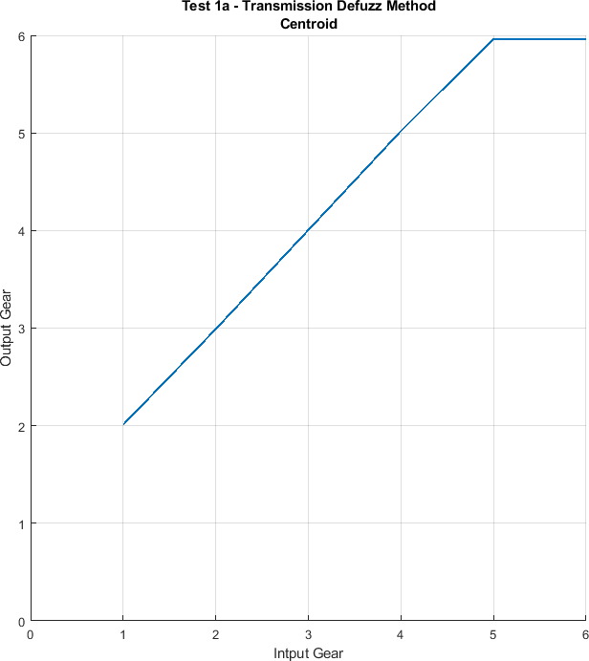

*Figure 15: Gear Box Centroid*

|  |  |
| --- | --- |
| *Figure 16: Gear Box Bisector* | *Figure 17: Gear Box Largest of Maximum (LOM)* |
| *Figure 18: Gear Box Middle of Maximum (MOM)* | *Figure 19: Gear Box Smallest of Maximum (SOM)* |

# Appendix C3

## Test 4a – Acceleration In Forward Gears

With Different Shifter Defuzzification Method

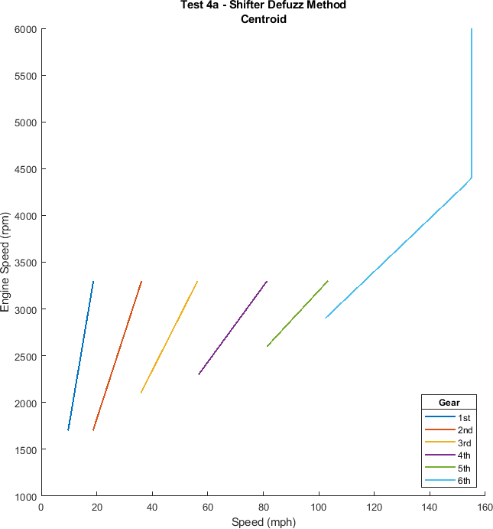

*Figure 20: Gear Box Centroid*

|  |  |
| --- | --- |
| *Figure 21: Gear Box Bisector* | *Figure 22: Gear Box Largest of Maximum (LOM)* |
| *Figure 23: Gear Box Middle of Maximum (MOM)* | *Figure 24: Gear Box Smallest of Maximum (SOM)* |

## Test 2 – Maximum RPM In Non-Forward Gears

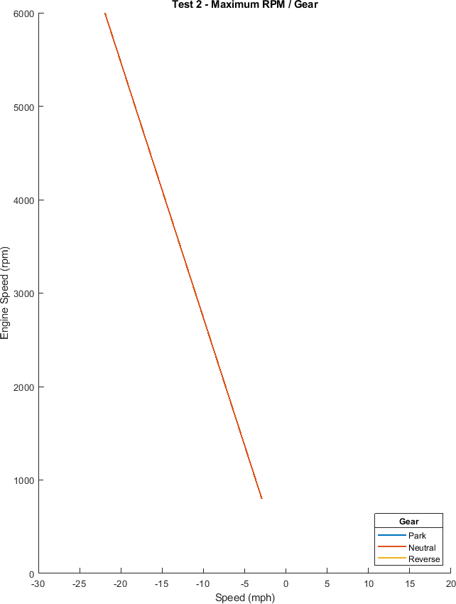

*Figure 25: Maximum RPM In Non-Forward Gears*

## Test 3 – Maximum RPM In Forward Gears

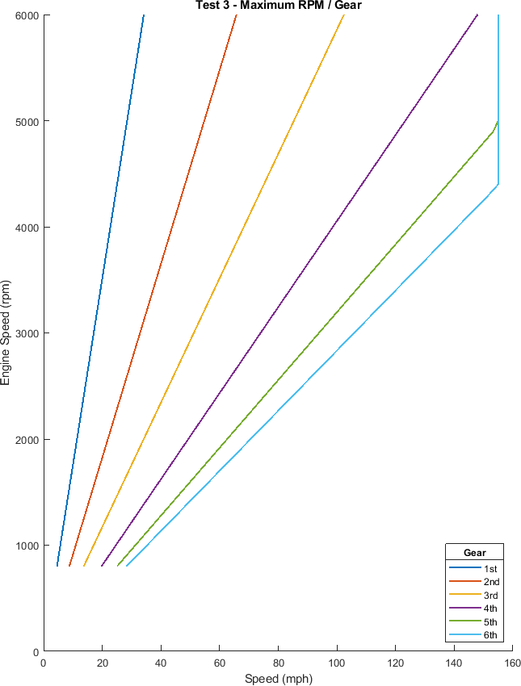

*Figure 26: Maximum RPM In Forward Gears*

## Test 4 – Acceleration in Forward Gears Starting At Previous Speed

|  |  |
| --- | --- |
| *Figure 27: Acceleration at 0.0 m/s/s* | *Figure 28: Acceleration at 1.2 m/s/s* |
| *Figure 29: Acceleration at 2.0 m/s/s* | *Figure 30: Acceleration at 3.0 m/s/s* |

## Test 5 – Acceleration in Forward Gears Starting At 1300 rpm

|  |  |
| --- | --- |
| *Figure 31: Acceleration at 0.0 m/s/s* | *Figure 32: Acceleration at 1.2 m/s/s* |
| *Figure 33: Acceleration at 2.0 m/s/s* | *Figure 34: Acceleration at 3.0 m/s/s* |

## Test 6 – Deceleration in Forward Gears

|  |  |
| --- | --- |
| *Figure 35: Acceleration at 0.0 m/s/s* | *Figure 36: Acceleration at -1.2 m/s/s* |
| *Figure 37: Acceleration at -2.0 m/s/s* | *Figure 38: Acceleration at -3.0 m/s/s* |

## Current version of Shifter

## Previous versions of Shifter

*Figure 39: 3D Plot of Current Shifter Output*

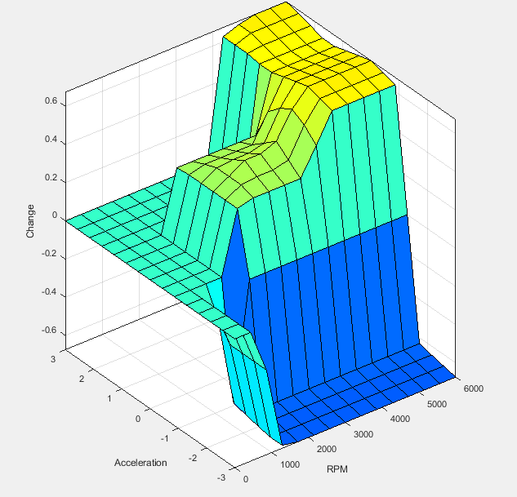 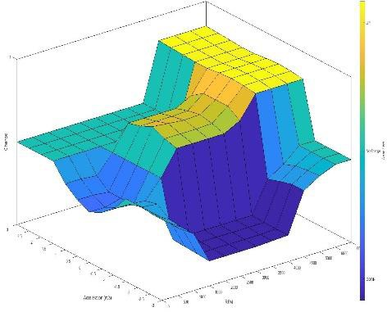

*Figure 40: Shifter V1.0 Figure 41: Shifter V2.0*

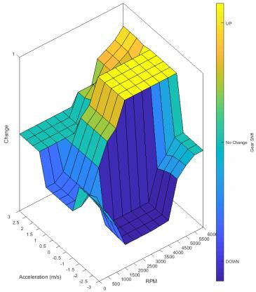

*Figure 42: Shifter V3.0*

# Appendix D2

## Current version of Gear Box

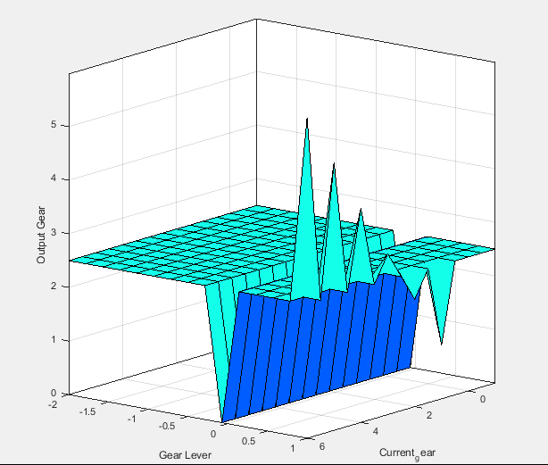

*Figure 43: 3D Plot of Gear Box Output*

# Appendix E

## Test 7 - Comparison

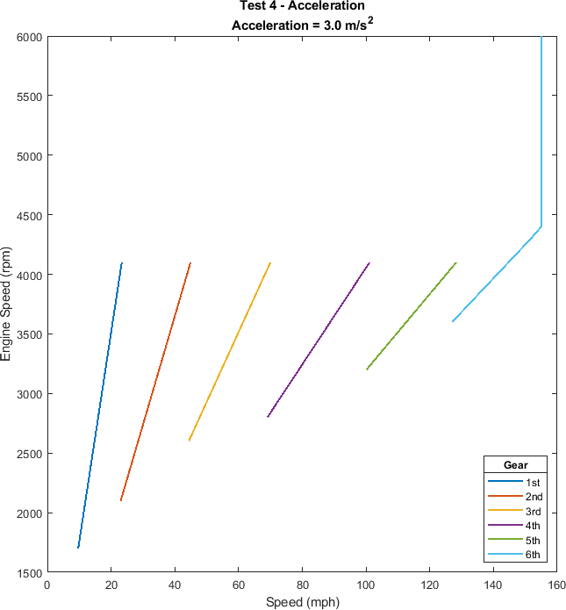

*Figure 44: Gear Changes Comparison System Output*

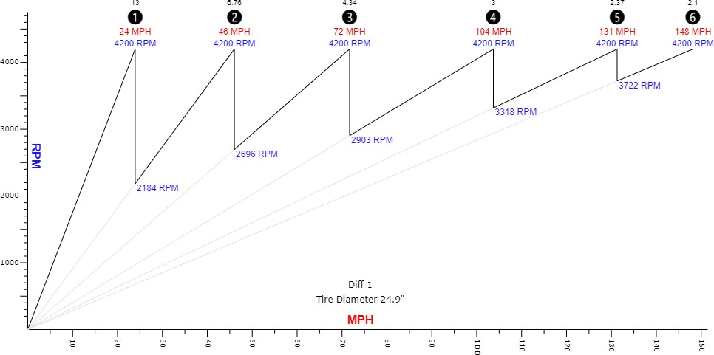

*Figure 45: Gear Changes Comparison Website Calculator Output*

Output of the Drive function compared with the output from a gear shift calculator (Block Layer, 2018)

# Appendix F

## System Block Diagram

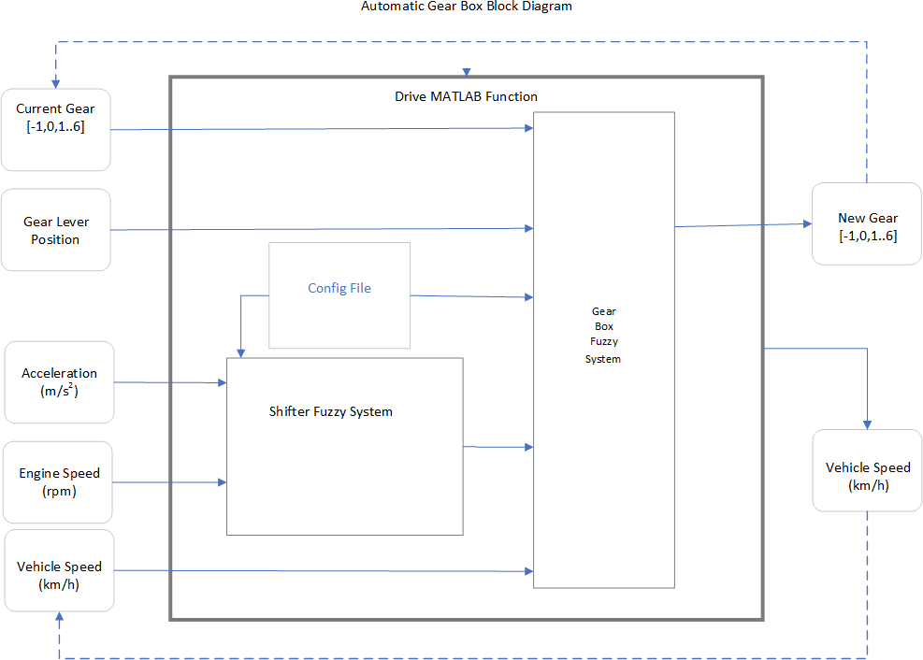

*Figure 46: Automatic Gear Box Block Diagram*